October – Bullying Prevention Month Toolkit
Social Post Captions

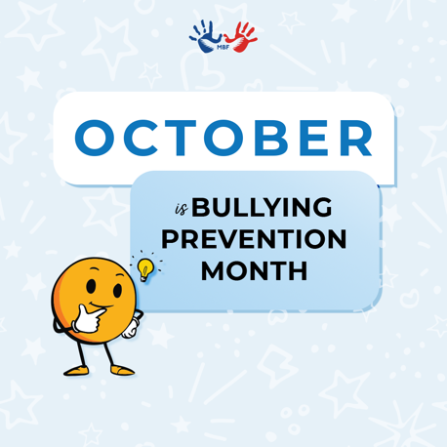
October is Bullying Prevention Month! Bullying can happen in different ways and may go unnoticed. And youth don’t often report bullying, but you can KNOW WHAT’S UP by learning the signs of bullying so you can help prevent it: https://www.mbfpreventioneducation.org/bullying-101/

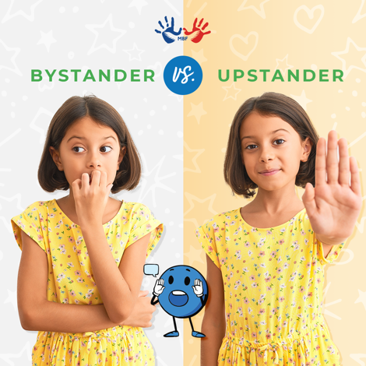
Do you know the difference between a bystander and an upstander? We teach youth that bystanders see bullying and don’t act, while upstanders take action to stop bullying or help the person being bullied. Talk to your child about being an upstander and check out more bullying resources in our MBF resource library to help you start a conversation: https://www.mbfpreventioneducation.org/resource/bullying/

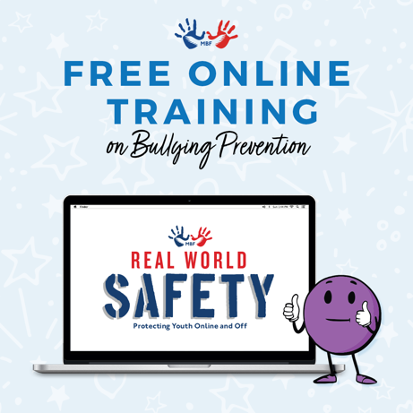
Children and teens across the country are spending more time than ever on devices exposing them to increased risks of digital dangers and cyberbullying. Learn how to protect kids online & off by taking “Real World Safety,” one of MBF’s four FREE one-hour online courses that can help you better protect the kids in your life. Get started here: https://www.mbfpreventioneducation.org/learn-more/online-training/

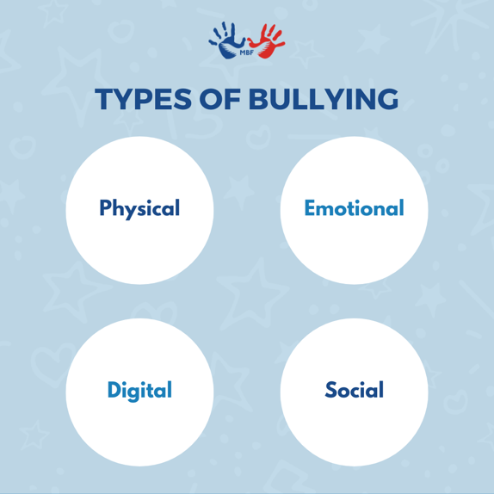
It’s important to understand the different types of bullying, as well as related indicators because youth often do not report these behaviors. READ: MBF’s Identifying and Reporting Bullying Safety Brief to learn more: https://www.mbfpreventioneducation.org/wp-content/uploads/2021/10/SB_Identifying-Reporting-Bullying_PEP_21.pdf

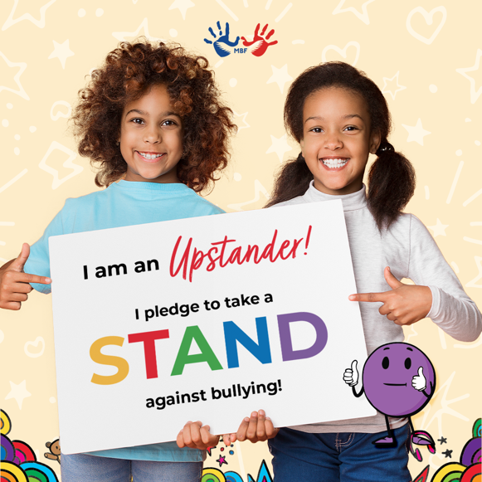
It’s Bullying Prevention Month, and we STAND AGAINST BULLYING! Stand with us by spreading kind vibes today.

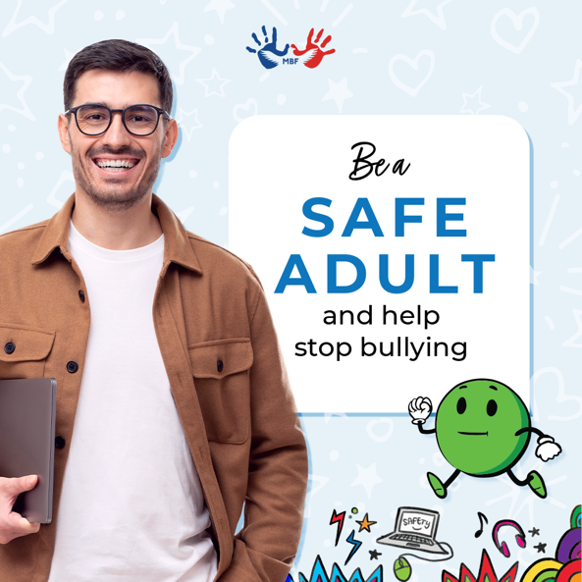
Education and intervention help prevent bullying. It starts by creating a culture of kindness, acceptance, and inclusion by teaching youth to recognize bullying behaviors and to be upstanders. Spread #KindVibes and help stop bullying!

